**Master Agent Configuration Guide**

This article was updated to support v12.0.1 and newer of Goliath Performance Monitor.

**Prerequisites**

Before continuing, please review the [Goliath Performance Monitor Prerequisites](https://support.goliathtechnologies.com/hc/en-us/articles/360024625734).

**Goliath Master Agent Overview and Diagram**

The Goliath Master Agent is used as a proxy/relay server to assist with agent connections to the Goliath Server.

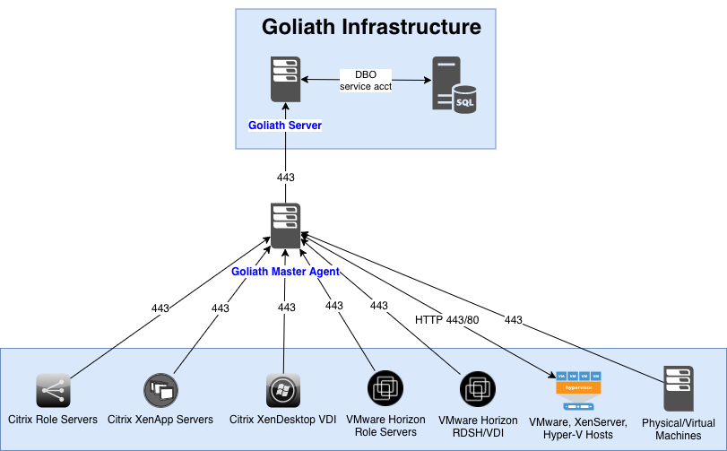

**Goliath Master Agent Installation Steps**

This section with provide instructions on how to deploy install and configure a machines to be a Goliath Master Agent. Please see the appropriate section that is applicable to your environment.

**A. Automated Installation via the Goliath Console**

1. Log into the Goliath Console and navigate to the **Configure - Inventory** Screen
2. Click the **New** button at the top of the page to add in the Master Agent(s)
   1. Enter in the Hostname of the Master Agent
   2. Click the ‘Add’ button next to the ‘Primary IP Address’ field and enter the IP address
   3. Use the dropdown to assign it to a group
   4. Use the dropdown to select the domain it is a member of. If you do not see the correct domain name there that is ok, just pick one and the agent will update it once deployed.
   5. Click Save and repeat for any additional Master Agent(s)
3. At the top of the page, click the **Manage Agents** button
4. If this is the first time an agent is being installed to a server, select the **Deployment Settings** button and enter administrative credentials (domain\user) in order to access the server. This is also applicable for machines that are being shown as ‘disconnected’ in the product.
5. Select the server(s) that you would like to update/install the agent on and click the **Install/Update Agents** button at the bottom of the screen.
6. Depending on the number of agents that are being installed or updated, the process may take about 2-10 minutes to complete. You will be prompted when the installation/update is complete.
7. Once the installation is complete, click the **Close** button to return to the Inventory page.
   1. Here, you can confirm the agents are connecting in by confirming that there is a green box in the **Agt** column for that machine.
   2. Please note, you may need to refresh the screen after a few minutes.
8. Once you see the Master Agent(s) connect back in, edit of them one at a time and do the following:
   1. Check the box to **Enable Master Agent Role**
   2. Enter the Master Agent Listen Port
      1. This is the port that the agent will use to communicate to the Master Agent. Default port is 443
   3. Save the entry
9. On the inventory page, click **Manage Agents** to update the agent on the master agent so the new module files are copied to the machine and configured

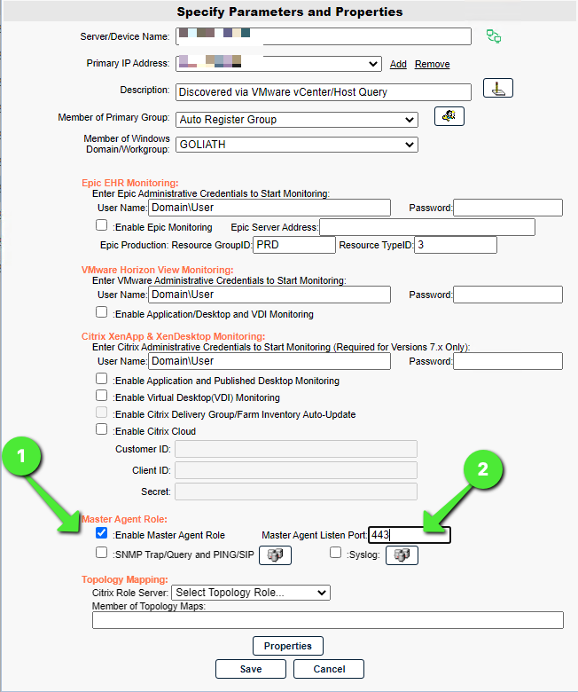

**B. Manual Agent Installation via Installer**

1. RDP into the machine that will be the Master Agent
2. Run the download & run the executable, **InstallAgent.exe**
   1. This can be dowloaded via https://____/installagent.exe where the blank is to be replaced with the IP or FQDN of the Goliath Server
3. Follow the installer prompts and enter the following when applicable:
   1. Enter the IP Address or FQDN of the Goliath Server
   2. Enter the Goliath Agent Port used for communication and click **Next**.
      1. By default, this is port 443
   3. Confirm the agent install directory
      1. default location is “C:\Program Files\MonitorIT” which can be modified
   4. Confirm the installation settings then click **Next** to start the installation.
   5. After 1-2 minutes the installation will complete, click **Finish**.
4. Copy over the following files to “C:\Program Files\MonitorIT” on the Master Agent if they are not already present. These files can be found on the Goliath Server at "C:\Program Files (x86)\MonitorIT\Bin" or "C:\Program Files\MonitorIT\Bin" by default
   1. MasterAgentModule.dll
   2. MasterAgentSetup.ps1
   3. MasterAgentUninstall.ps1
5. Open the Goliath web console and confirm you see the Master Agent(s) connected via the **Configure - Inventory** screen
6. Once connected, edit the Master Agents(s) one at a time and do the following:
   1. Check the box to **Enable Master Agent Role**
   2. Enter the Master Agent Listen Port
      1. This is the port that the agent will use to communicate to the Master Agent. Default is 443
   3. Save the entry
7. Restart the Master Agent by clicking the green box in the "AGT" column next to the Master Agent Server.
8. After about 5 minutes the IIS app pool will be present on the Master Agent server.

**Deploying and Connecting Agents**

This section with provide instructions on how to deploy the Goliath Intelligent Agent to your environment so that the connections go to the Master Agent. Please see the appropriate section that is applicable to your environment.

**A. Automated Installation/Update via the Goliath Console**

1. Open Goliath Performance Monitor and select the **Configure** tab and then the **Inventory**
2. At the top of the page, click the **Manage Agents** button
3. Select the **Deployment Settings** button and use the dropdown menu to select the Master Agent the agent will be connecting to.
4. Enter administrative credentials in order to access the server and click **OK**
5. Select the server(s) that you would like to update/install the agent on and click the **Install/Update Agents** bottom at the bottom of the screen.
6. Depending on the number of agents that are being installed or updated, the process may take about 2-10 minutes to complete. You will be prompted when the installation/update is complete.
7. Once the installation is complete, click the **Close** button to return to the Inventory page. Here, you can confirm the agents are connecting in by confirming that there is a green box in the **Agt** column for that machine. Please note, you may need to refresh the screen after a few minutes.

**B. Manual Agent Installation via Installer**

Below are instructions for installing and/or updating the Intelligent Agent for a Windows 2012 R2 or newer machine. **Please note, there is no reboot required when installing or updating the agent**.

1. RDP or log into the machine where you would like to install the In
2. Exit all programs
3. Run the downloaded executable, **InstallAgent.exe**
   1. This can be dowloaded via https://____/installagent.exe where the blank is to be replaced with the IP or FQDN of the Goliath Server
4. Enter the IP Address or FQDN of the Master Agent server.
   1. If you have more than one Master Agent that is being load balanced, enter the information for the VIP
5. Confirm the Goliath Agent Port and click **Next**.
   1. The default port is 443
6. Confirm the agent install directory
   1. this should remain “C:\Program Files\MonitorIT” unless there is no C drive.
   2. **DO NO INSTALL INTO THE WRITE CACHE DRIVE for PVS**
7. Confirm the installation settings then click **Next** to start the installation.
8. After 1-2 minutes the installation will complete, click **Finish**.

**Configuring Remote PING & SNMP Monitoring**

If you are interesting in configuring PING or SNMP alerts for your devices/machines that are connecting through the Master Agent you'll need to:

1. Navigate to the **Configure - Inventory** page
2. Select the entry for the Master Agent and click **Edit**
3. At the bottom of the pane under the **Master Agent Role** section, check the box for **SNMP Trap/Query and PING/SIP** and then click on the icon to the right of the text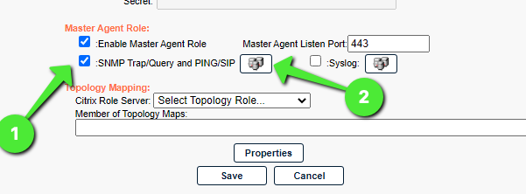
4. A new pane will open with a device selection tree. Select all of the applicable devices that connecting via the selected Master Agent and then Save the selections
5. Save the updated Master Agent configuration
   1. This is now telling the Master Agent to initiate the PING instead of the Goliath Server
6. Repeat the above steps per Master Agent (if applicable)
7. Configure the applicable monitoring:
   1. [PING Monitoring](https://support.goliathtechnologies.com/hc/en-us/articles/360045916854)
   2. [Configure SNMP Trap Monitoring](https://support.goliathtechnologies.com/hc/en-us/articles/1500001853962)
   3. [Citrix ADC (Netscaler) Monitoring Module](https://support.goliathtechnologies.com/hc/en-us/articles/4405710600471)